

**Reimbursement**

**Document/Receipt Guide**

The following guide will University of Miami

2019-2020

The following guide will provide examples of what documents are needed to be submitted with your reimbursement, including receipts from stores, flights, hotels, and more. Please keep in mind that the items and dollar amounts listed in the receipts are not meant to reflect current SAFAC guidelines. For an updated list of SAFAC guidelines, please visit [www.miami.edu/SAFAC](http://www.miami.edu/SAFAC).



**Documentation/Receipt Overview**

To efficiently process your student reimbursement, the University of Miami’s Disbursements office requires proper documentation as back-up for your request. Documentation is required for all reimbursement requests and will not be accepted if incomplete. At the minimum, your reimbursement should include two documents: an itemized receipt and back-up documentation for the purpose of purchase (event flyer, meeting email invitation, etc.).

**Regular Reimbursement Requests**

For non-travel reimbursements, documentation must include a copy of the final invoice or receipt rendered by the vendor at the time of purchase. Invoices and receipts must be properly itemized—lump sum totals for multiple different items on a single receipt are not acceptable. They must also have the total amount paid or show a $0 balance is due.

Reimbursement requests for items purchased for specific events or meetings must also include a flyer from the event showing the event date and details, or an email invitation for the meeting.

**Travel Reimbursement Requests**

All travel requests require a daily schedule and itinerary that include the purpose and details of travel. Additionally, refer to this document/receipt guide to determine the appropriate documentation for each specific travel category. Like the regular reimbursement requests listed above, they need to be itemized and have the total amount paid or show a $0 balance is due.

**Back-Up Documentation**

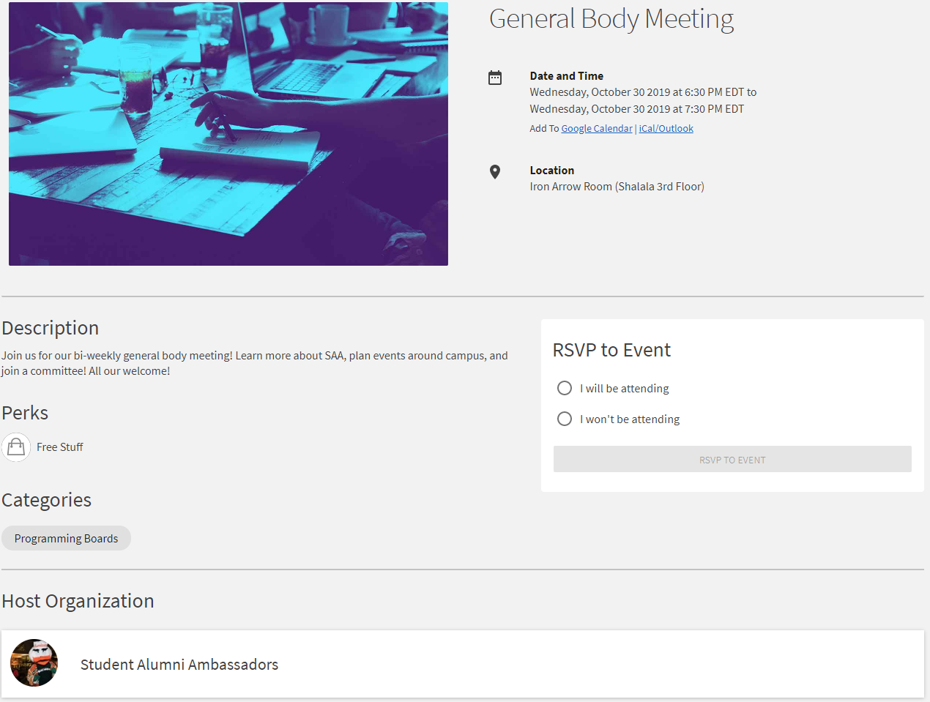

Shows date and location

Has the organization’s name

SAFAC

Name of the event is shown

Has the organization’s name

Shows date and location

**Example of a GOOD store receipt**

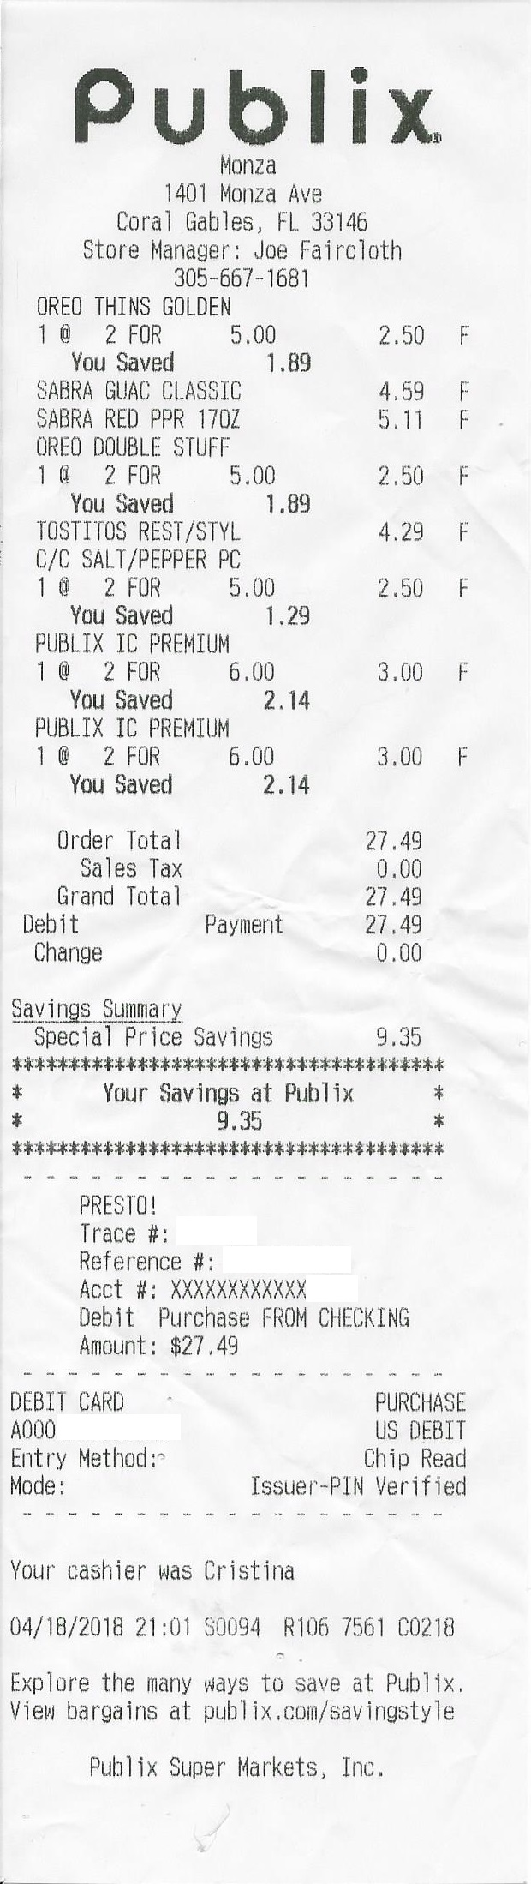

Receipt is legible and complete

The payment method indicates proof of payment

Name & Contact Information of Vendor

Itemized to show price per item for all items purchased

Shows date and time of purchase

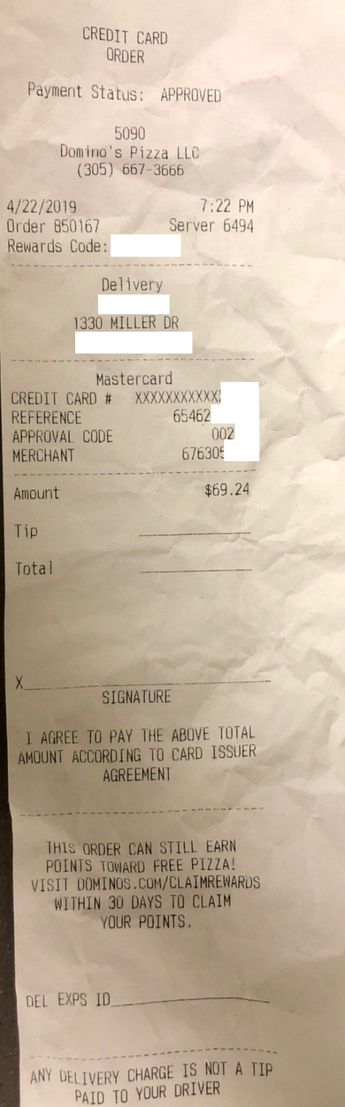

**Example of BAD receipts that will NOT be accepted**

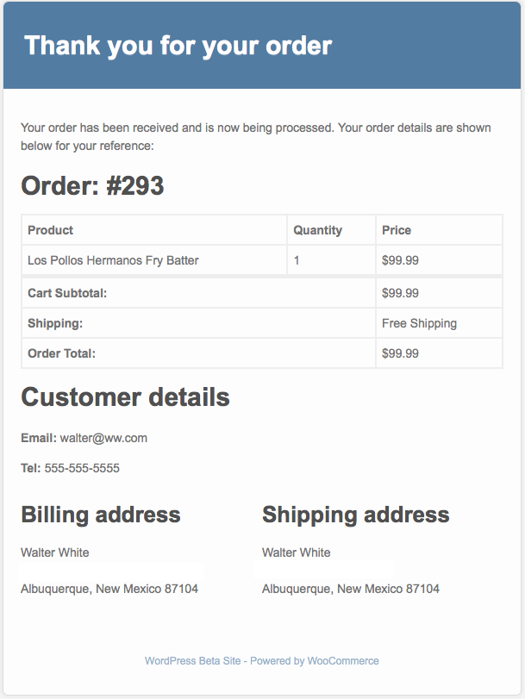

This is not itemized, so it does not show all the items bought. An itemized receipt is required

This is an order confirmation, not a receipt. It does not have any payment details on it. The receipt must show that payment has been made (with the payment method) or indicate that there is a $0 balance due.

**Amazon Receipt Guide**

Step 1: Login to your Amazon account

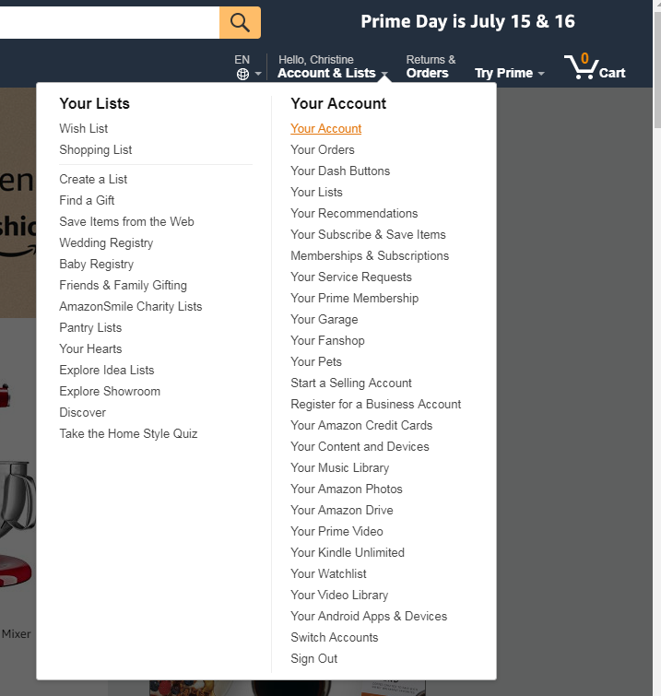Step 2: Hover over “Accounts & Lists” and click “Your Orders”

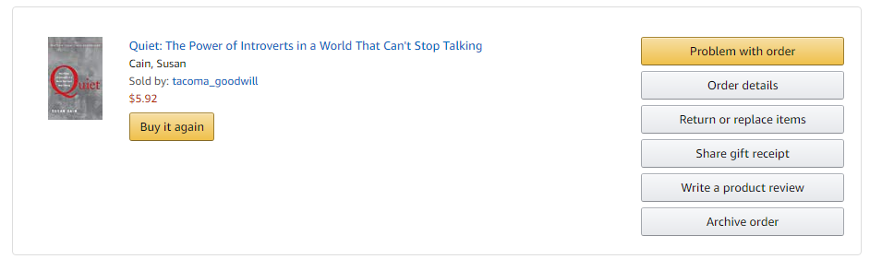Step 3: Click “Order details”

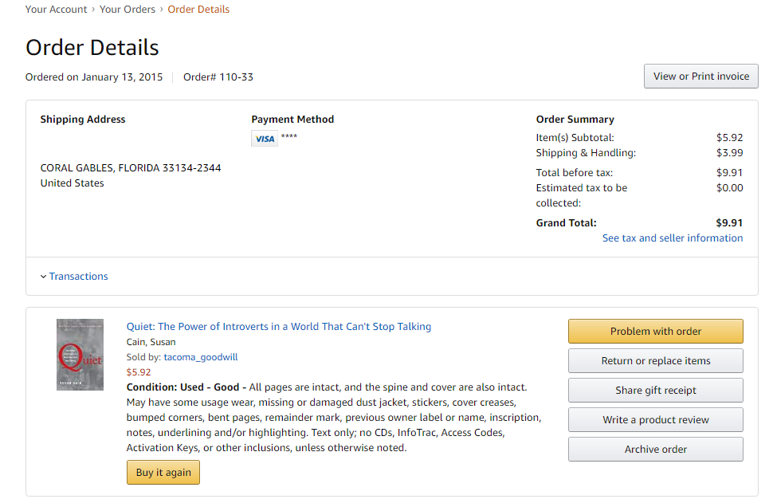Step 4: Click “View or Print Invoice”

Itemized to show price per item for all items purchased

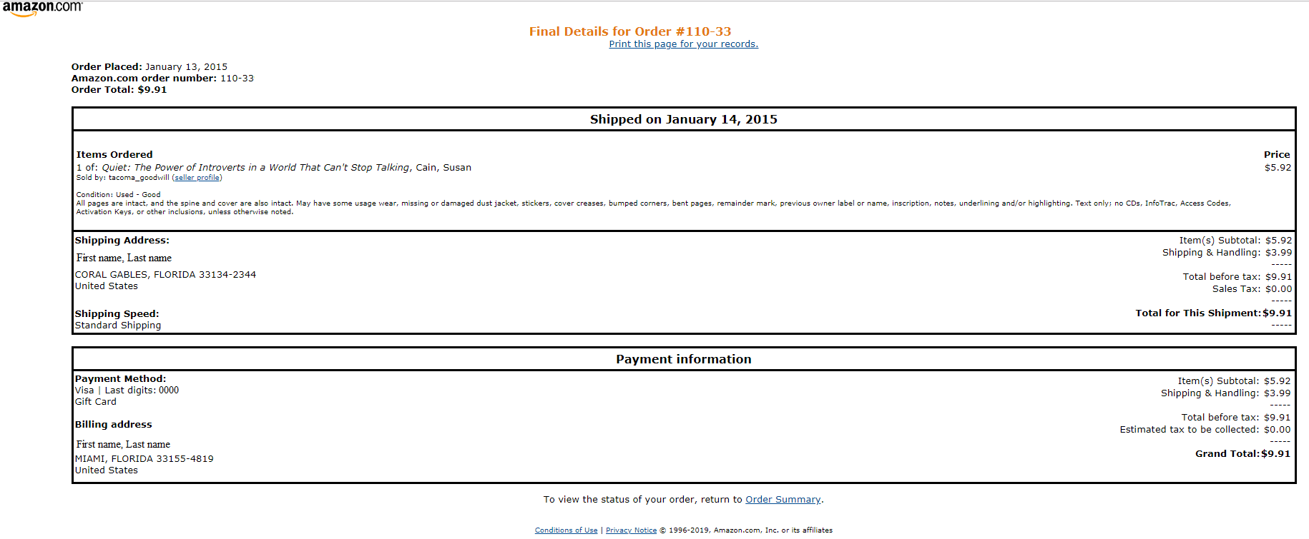Step 5: Attach this as your receipt

Shows date of purchase and name of vendor

This name must match the student requesting reimbursement

The payment method indicates proof of payment

Grand total is shown to verify if any tax, shipping, or discounts have been included

**Flight Receipt Guide**

Date, time, and location of flight must be shown

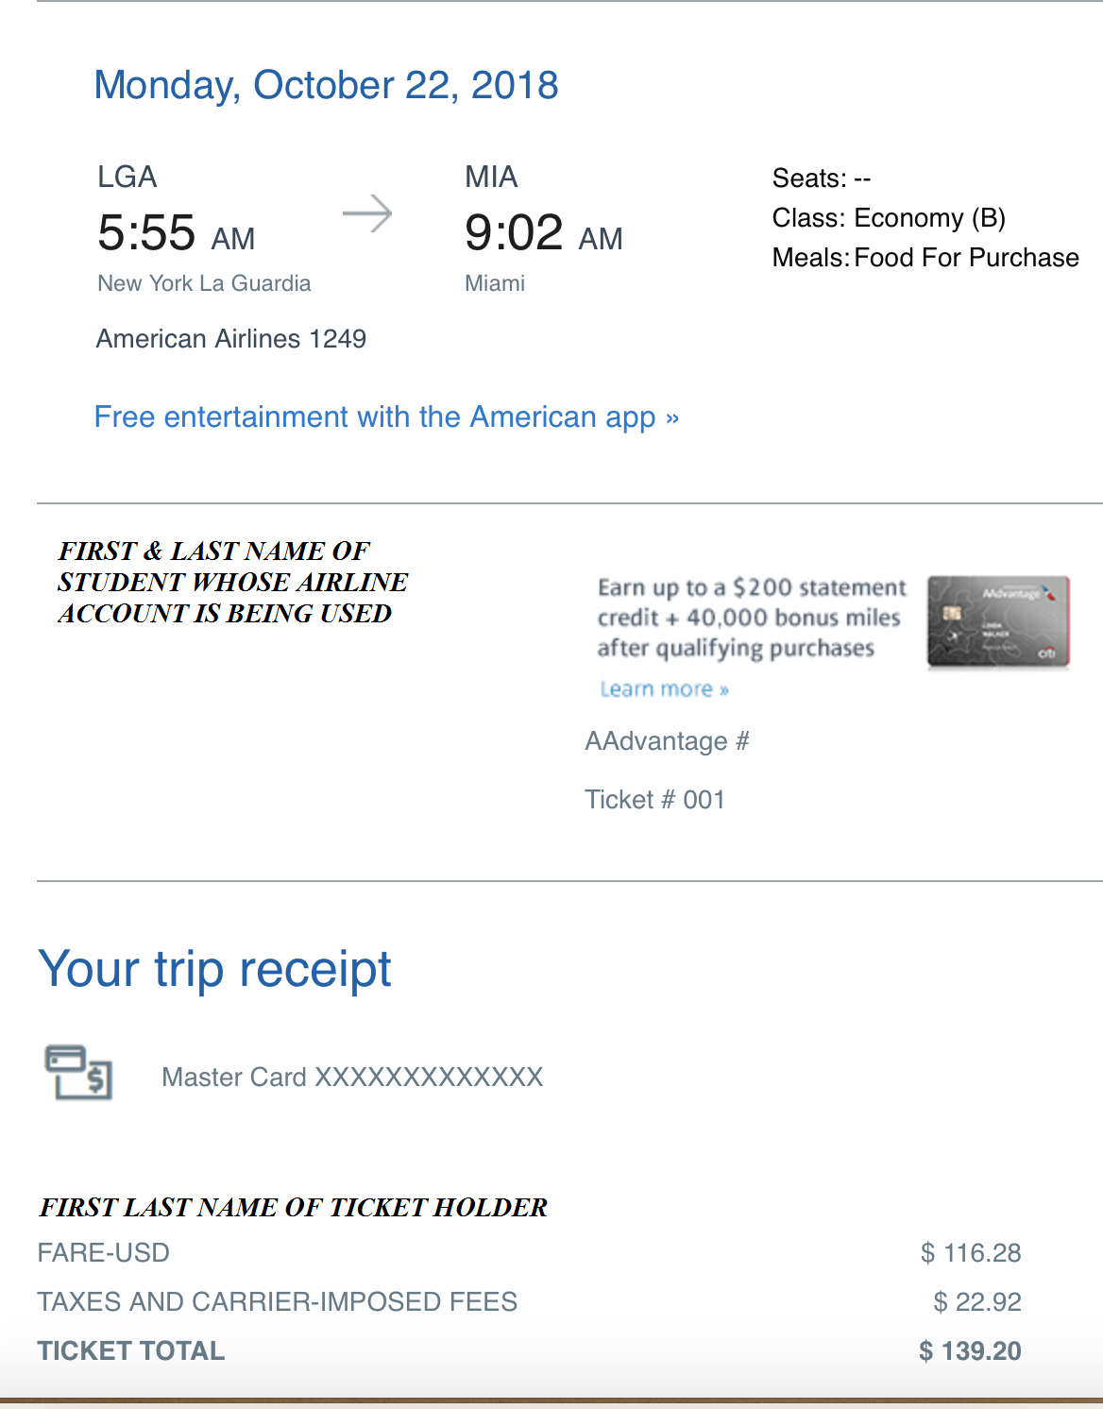

This must match the person requesting reimbursement

Name of student the ticket is for

Grand total has amount paid and shows taxes, fees, and discounts

Payment method indicates proof of payment

Airline is listed

Flight class must be listed

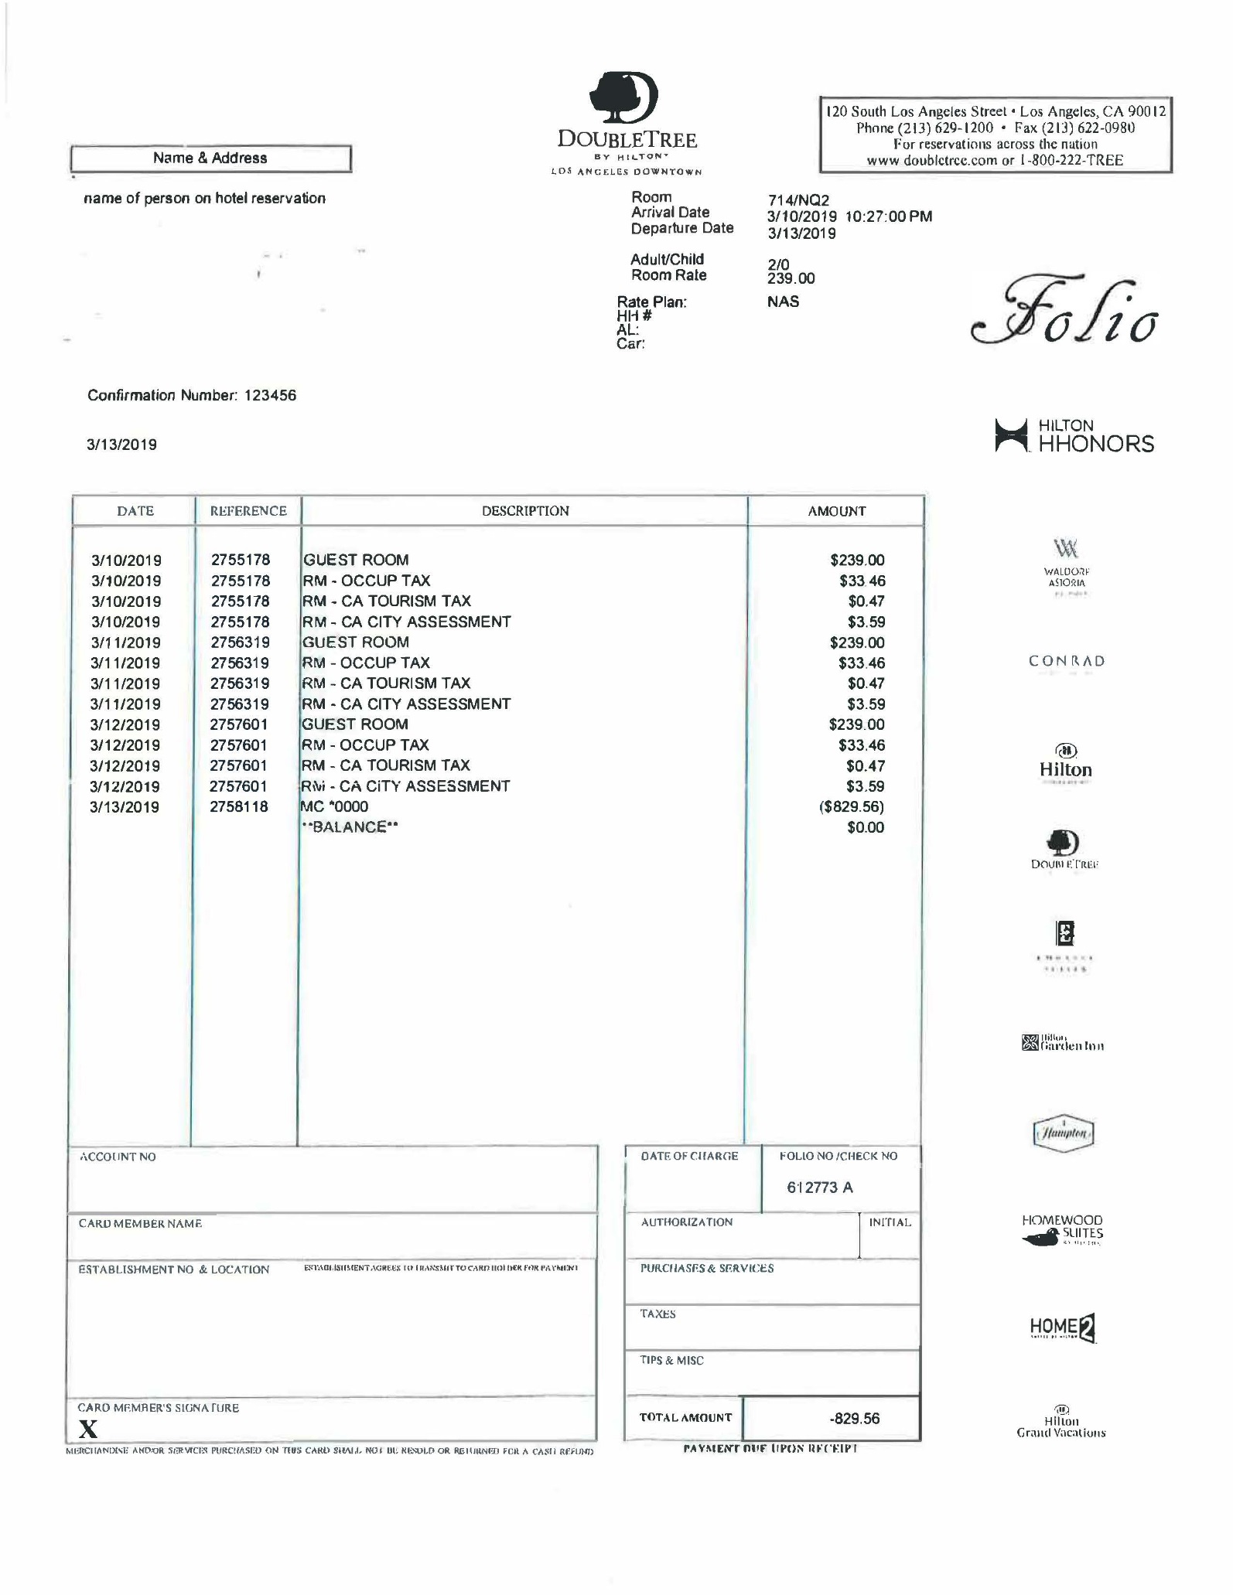

Hotel name, location, and contact information is shown

This must match the person requesting reimbursement

Dates of hotel stay are shown

Itemized to show daily rate, taxes, fees, and total amount paid

Payment method and $0 balance is proof of payment

Room number is required, especially if there is more than 1 room booked

**Hotel Receipt Guide**

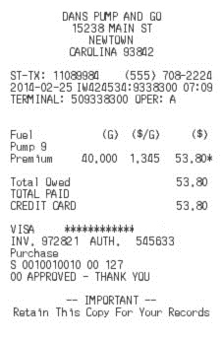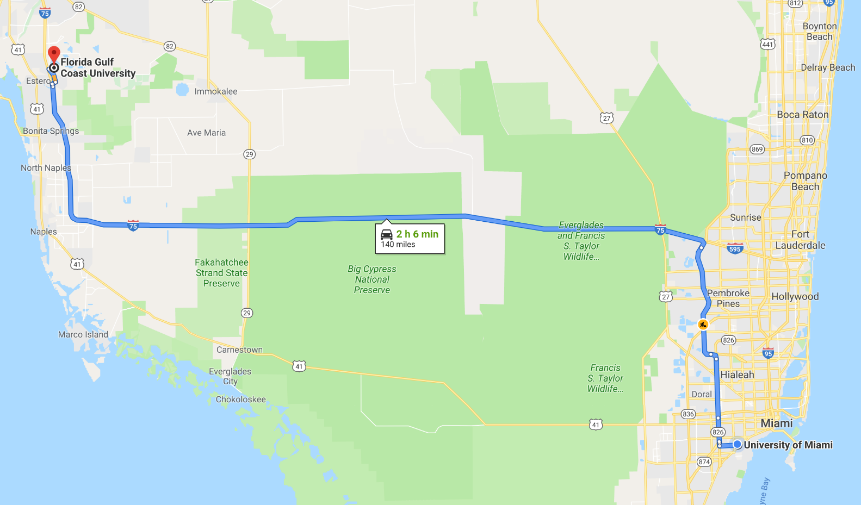

**Mileage Receipt Guide**

Name of gas station and address are listed

The price per gallon, number of gallons, and total price are clearly listed

The payment details are proof of payment

**OR**

Shows the total number of miles

Starts at the University of Miami and ends at the destination