Student & Non-Employee
Reimbursement Guide

The following guide will University of Miami
2019-2020
The Non-Employee and Student Expense Reimbursement Form, found at miami.edu/expenseform, allows students to claim funds spent on behalf of their organization directly from their organizations’ accounts. This form should only be completed by University of Miami students as well as non-employees. Advisors and other University employees wishing to submit a reimbursement request should do so via the Expense Report tab in Workday.

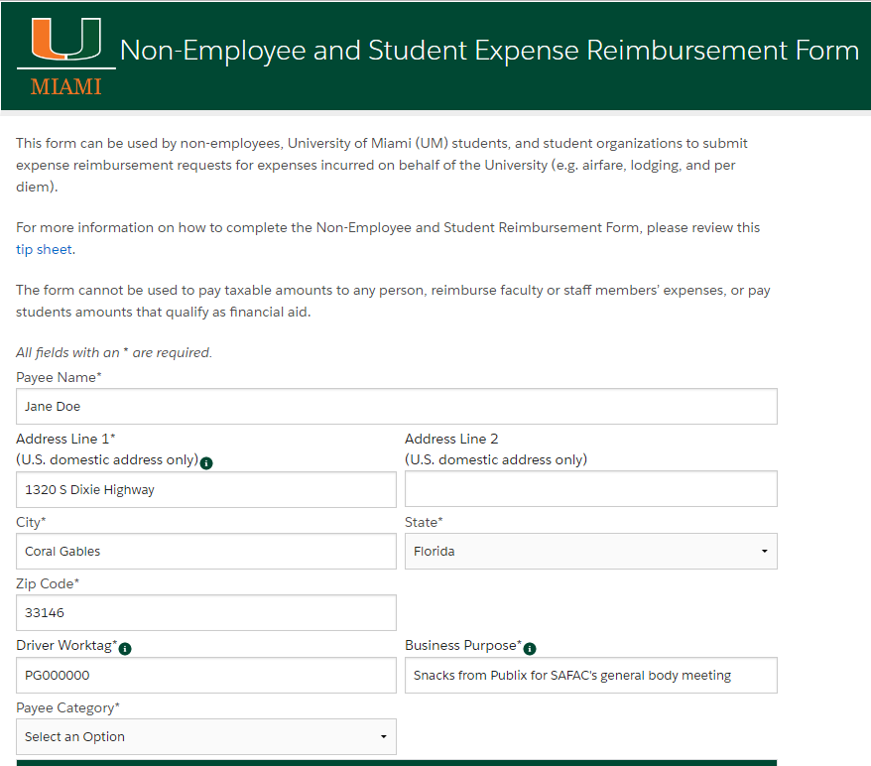
Visit www.Miami.edu/expenseform to launch the online reimbursement form.
Address the payee would like the check mailed to
The payee is the person requesting reimbursement
The account to be reimbursed out of. If you need to split the reimbursement between two accounts, please submit two different reimbursements, as this form only allows you to select one
If the payee would like the check held at Ashe for pickup instead of being mailed, please write in all caps, “HOLD FOR PICK UP” in this section in addition to the business purpose
Explain the reason for reimbursement
Select the option from the drop down menu that describes the payee: student, non-employee, etc.

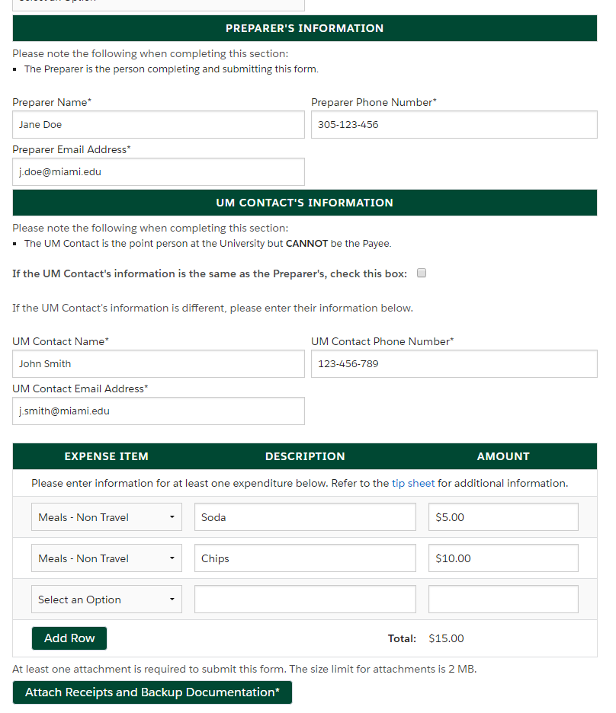
Attach itemized receipts and backup documentation (flyer, event invite, email, etc.). Please visit miami.edu/safac for details on proper documentation
Description and price of the items requesting reimbursement for
Select the option from the drop down menu that most closely describes your reimbursement

